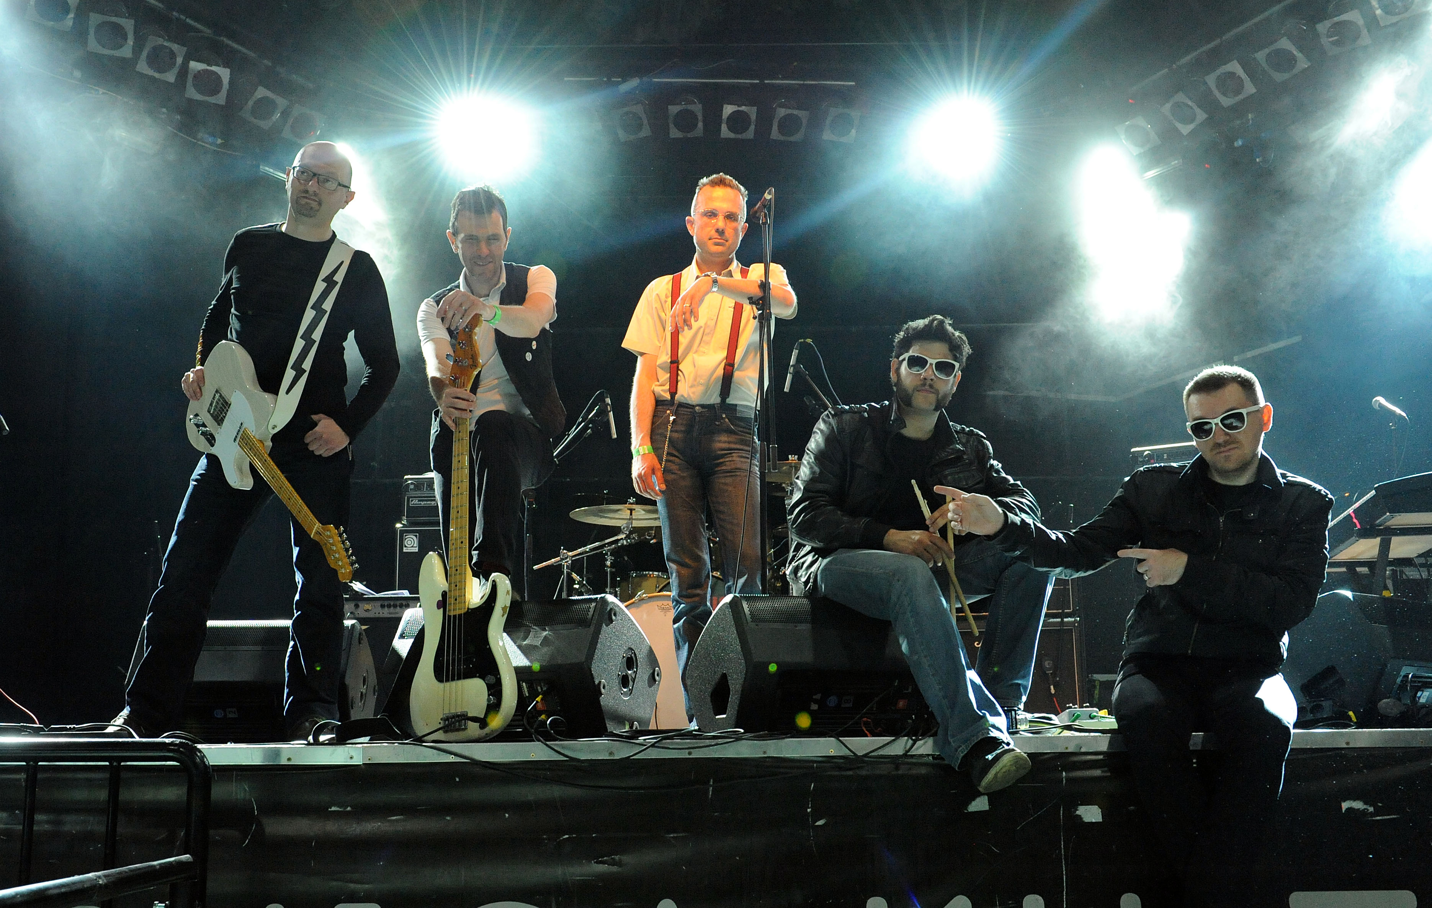

EROTIC BILJAN & HIS HERETICS
Screamadelic Boom Boom Garage Rock‘N’Roll!!!

SHORT BIO:
During last years club and festival stages are home for Erotic Biljan and his Heretics. They started carrier with frantic covers from Back from the grave and Pebbles compilations and now with their own songs are putting the Heretics name on garage charts. With mighty garage riffs, thundering rhythm, catchy melody and energy performance Heretics are confirmed concert attraction.

Band who played with number of legends like MC5/DKT, Queens of the stone age, Supersuckers, The Cynics, The Fuzztones, The Nomads, and with considerable mileage on the road and long time in underground.

Long time has passed when there were two bands - one playing 50s blues and the other 70s punk rock - when members of these two bands took a common ground in 60s garage music and founded Erotic Biljan And His Heretics. During these more than ten years, Heretics had played around the Europe their own shows and giving support for such garage bands as Supersuckers, The Fuzztones, The Morlocks and The Cynics and earned reputation as “Screamadelic Garage Rock’n’Roll”, which became their slogan and description of their frantic appearance. Also, if one wants to describe the music of the Heretics, he’ll remember and put together the early roots of Detroit sound with touch of modern love. Coming from Croatia, homeland of Erotic Biljan and His Heretics with first album “Supersticky” and so named single debut, made remarkable outcome as No3 on Croatian national VIP Club list.

Their second album „H is for Heretics“ („Dancing Bear“, November 2010.), put distinctive mark on music scene in Croatia. Almost all critics in paper, magazines, web-zines put the „H is for Heretics“ on top places in album of year charts for 2010.

The band is now working on new material, expecting to release in year 2015. From new material two singles, “Frenzy” and “Disgrace”, has been released in 2014. Single “Frenzy” has been put on few “Best Croatian singles charts in 2014.” and been presented by Genya Ravan at her Goldies Garage show within Steven Van Zandt radio channel Underground Garage.

LINEUP:
Electric a.k.a. Erotic Biljan = wah & lead guitar
Jura the Wildman = lead vocals
Screamin' Yeah Zhalac = rhythm guitar, blues harp & back vocals
Mislav the Phantom = bass guitar
Jan the Gun = drums & precussions

SHARED STAGE WITH:
DKT / MC5 (USA), Queens of the stone age (USA), Supersuckers (USA), The Cynics (USA), The Morlocks (USA), The Nomads (SWE), Juliete and the Licks (USA), Kings Of Nuthin (USA), Fuzztones (USA), The M.A.S.S. (GB), Meteors (GB), Horrorpops (DK), The Lombego Surfers (CH/USA), The Staggers (AUT), Rodriguez (AUT), The Giraffe Men (GER), The Babies (CRO), The Mad Men (CRO), The Bambi Molesters (CRO), The Spoons (CRO), Messerschmitt (CRO), Overflow (CRO), Muskat Hamburg (SLO), Res Nullius (SLO), No Rules (BIH), Voodoo Cadillac (BIH)… and many more!!!

REVIEWS:

“H is for Heretics”, 2010. (Dancing Bear)

"Erotic Biljan & His Heretics - H Is For Heretics: The essence of Heretics is garage-rock of the 60s the Sonics style with a touch of wild rhythm & blues and sharp proto-punk of the 70s, as well as the cult garage punk rock bands of the 90s such as New Bomb Turks and the legendary Scandinavian rock'n'roll bands such as the Nomads. This is world class rock'n'roll which is, unfortunately, ignored here in Croatia."
= Aleksandar Dragas, JUTARNJI LIST, 20/12/2010

"On their second album, Biljan and his Heretics polished their garage sound, and with a lot of experiance and gigs behind them they really sound great. This is a high quality combination of garage and modern rock, as are their guitar stunts. This album (and the band) shouldn't be ignored by any fan of rock or furious riffs. As a guest on the album they have Remi from Elemental, who showed her new, exciting face in this collaboration." = Marija Lalic, NET.hr, 12/12/2010

EB & HIS HERETICS - H IS FOR HERETICS IN TOP TEN BEST CROATIAN ALBUMS IN 2010
No. 03. = JUTARNJI LIST = Aleksandar Dragas
No. 04. = MIKROFONIJA.com = Mirsad Mujkanovic-Hadzo
No. 01. = GLAS SLAVONIJE = Daniel Radman
No. 04. = RTL Teletekst / RTL.hr /VIP.hr = Vedran Harca
No. 04. = MTV / EXIT Festival = Sanjin Djukic
No. 04. = GLAS ISTRE = Tea Tidic
No. 05. = T-PORTAL.hr / CANTUS / PLAN B = Bojan Muscet
No. 03 .= MUZIKA.hr = Kreso Blazevic
No. 04. = VIP.hr = Andjelo Jurkas
No. 03. = MUZIKA.hr = Sinisa Miklauzic
TOP 10 ALBUMS chosen by musicians from Istria
No. 09. = Edi Cukeric
No. 01. = Boris Bjelica DJ Bebetto
No. 02. = Ivo Zuban DJ Filjo

“Supersticky” 2007. (Dancing Bear)

SUPERSTICKY, CD, Dancing Bear, 2007- debut album review
PLAYBOY, Croatain Edition, September 2007
"If you don't fall for a super sexy cover (where have all the LP's gone…), you will definitely fall for the high quality garage rock. The band gives us screamadelic garage rock and roll in high doses, but the audiences in Spunk and similar places have already been enjoying that for a few years now. Rock is alive and kicking, The Heretics are wild and strong, and we won't give them the fifth bunny only because you have to check them out live! "
Rating: 4 bunnies'

SUPERSTICKY, CD, Dancing Bear, 2007- debut album review
VIP PORTAL, by Angelo Jurkas
''The Heretics' debut album is a genuine little entity and rarity on the Croatian rock scene… The sound is dirty, loud, simple, minimally produced and as 'live' as possible, it's rich with guitar distortions, while the singer is very direct… The album owes both to MC5 and the Sonics, as their idols, and to the whole Crypt records catalogue which is a kind of garage/trashy r'n'r encyclopedia in itself … Supersticky, "Boom Boom In The Sonic Room" and "Devil Stole My Records" are the examples of bombastic and great rhythmical adrenaline garage rock pieces of which even the leaders of the genre would be proud. If only our radio scene were fresher and healthier, we would hear these songs on the radio again and again... ''

FV Festival 2005 - First class festival with cultural identity … 07/12/2005
"Without question the best band that evening was EB&HH with their powerful musical force which engrosses you thanks to its rich musical resonance. Roughly, the framework of their poetics is the cross between The Sonics and the Stooges, with some amazing guitars, top-notch singer and hypnotic magnetism of the rhythm section. Unbeatable. It was perhaps why, surprisingly, the very important pioneers of the Swedish rock'n'roll The Nomads seemed so drab…"
MARJAN OGRINC (DELO, Slovenia)

Review of the GARAGE EXPLOSION festival in the MUSKA magazine - May 2005
''…The concert had its highpoint with the performance of Erotic Biljan And His Heretics. They are a unique Croatian reply to the notorious Dirtbombs, they also mix together soul, punk, rhythm & blues motives, and they have a spontaneous and direct relationship with audience thanks to the unstoppable frontman. Frontmen like him are hard to find in our neighbourhood…''
IGOR BASIN - BIGor (magazine MUSKA, Slovenia) HERE !

ROCK EXPLOSION - Garage Explosion Fest review...30/03/2005
''Performance by Erotic Biljan & His Heretics is virtually a discovery of a decade because of musical perceptiveness, lucidity, ease and a feeling for tempo, accentuation and dynamics, for the rhythm as well as improvisation. It's first-class and as good as the best of what has appeared in the last ten years… …coming from Croatia is a new generation of creative, innovative and modern rock which has to make its mark in the world so that musical creativeness and integrity is satisfied.''
MARJAN OGRINC (DELO, Slovenia)

ELECTROCUTED by EROTIC BILJAN AND HIS HERETICS - CD review...30/01/2005
''Somewhere in between psycho-trash and garage rock'n'roll, Erotic Biljan & His Heretics (in any case, guys deserve 'best name of the year' award) lean towards one of the darkest parts of western rock, rock'n'roll born at the bottom of joyless and dark holes, in the garages where the smell of the filthy oil opposes the overstuffed decibels, in those caves where mould drips off the tones, u hangars where the spirits are invited to dance bop or watusi. From Sonics to Cannibals, from Trashman to Mummies, from Love to Makers, fathers and older brothers of these incredible Croats have set the foundation of a religion which turned the hardest riff into a noisy and degenerate hymn, the most frenetic rhythm into hormonal and pelvic ritual, and the most gentle melody into a perverse and obsessive prayer. This music is that much more special, because it's timeless and inescapable, it permeates all and turns it into salt which is the fermentation and the cement. When talking about rock groups, we shouldn't forget that only trash-garage imposes its church-like status, open to all the trends and to all the lost people on Earth, but still remaining a church. Our erotomaniac Biljan is one of its greatest priests. Hallelujah! In the name of the Vox, fuzz and the crypt.''
(442eme RUE Radio/Fanzine, France)

RELEASES:

ELECTROCUTED by EB & HIS HERETICS, 2004.
"Zero" album
CD, Listen Loudest!, early demos

SUPERSTICKY, 2007.
First official album
CD, Dancing Bear

H IS FOR HERETICS, 2010.
Second official album
CD, Dancing Bear

SINGLES:
Frenzy, internet, Dancing Bear, 2014.
Disgrace, internet, Dancing Bear, 2014.

COMPILATIONS:

NO WAY OUT
Dead By Mono Records, UK, 2011.
Song: Burnside Blues

EX YU Bastards 2011.
Song: R'n'R Revolution No5

HGF RETRO 1996-2009, 2010.
compilation CD, Spona
song: Kerosene Lips (from Supersticky album)

Rock ²" (Rock na kvadrat) , 2009.
compilation, double CD, Dancing Bear
song: Remember (from Supersticky album)

YOUNGUNZ TOUR 4, 2007.
compilation CD
song: Tips From The Lips

BOMBARDIRANJE NEW YORKA 10 , 2004.
(BOMBING OF NEW YORK no.10)
compilation mp3 CD, Listen Loudest!
song: Boom Boom In The Sonic Room

BOMBARDIRANJE NEW YORKA 7, 2001.
(BOMBING OF NEW YORK no.7)
compilation CD, Listen Loudest!,
songs: Fat Chick Dressed In Black / Remember

FESTIVALS:
Pekarna Gustaf: Garage Explosion Festival (Maribor, Slovenia)
Pekarna Gustaf: Garage Afterparty (Maribor Slovenia)
Mladi Fest 2004 (Rogatec, Slovenia)
20 years FV Music 2005 (Ljubljana, Slovenia)
YoungGunz Tour (Novo Mesto, Slovenia)
Garage FIRE, 2010. (Belgrade, Serbia)
IN music festival, 2007. 2008.
North West Rock Fest 2006 (Varazdin, Croatia)
Dugave Open Air 2006 (Zagreb, Croatia)
Park In Zagreb fest: Purgeraj (Zagreb, Croatia)
3FF festival (Cakovec, Croatia)
WideView Festival (St. Andra im Lavanttal, Austria)
St. Mary Rock Festival 2005 (St.Marien/Graz, Austria)
Kulturhaus: Power Tour Festival (Weiz, Austria)
Rock Im Vulkanland 2005 (Auersbach, Austria)
Brucosijada Filozofskog Fakulteta 2004 i 2005 (Zagreb, Croatia)
Heineken Music Fest 2004 (Zenica, BIH)

TV shows:
GARAŽA, 2009. Croatian National Televison show
VECERAS S JOSKOM LOKASOM (HTV) live on TV show
RADIO TV (VTV) live on TV show
HEINEKEN MUSIC FEST 2004 final evening (OBN TV) live on TV show
SKLIZALJKA (OTV, RI-TV…) live on TV show
ZVUCNJAK TV show (Croatian TV - HTV1)

CONTACTS:
E-mail: heretics@hi.t-com.hr
EB & His Heretics official web site: http://www.heretics.t-com.hr/
EB & His Heretics on MySpace: http://www.myspace.com/eroticbiljanandhisheretics
Facebook:
Phone/GSM
Tomislav 00 385 91 51-029-04 (contact for the English language)
Biljan 00 385 91 52-789-65

Sincerly yours
EB & His Heretics

